You can win this journal!!
Open to students in grades 3- 6

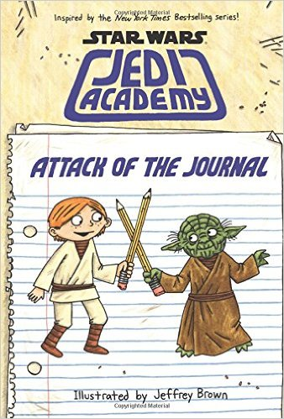
Just check out any of the Star Wars Jedi Academy books from the library during the months of April and May and you will get to fill out an entry form. If you answer the three (3) Jedi Academy questions correctly, your name will be put into a box. One entry will be selected from the box on Friday, June 3rd and will win this journal!

